Quick guide for LinkitOne with AWS IoT

This is temporary guide for using LinkitOne with AWS IoT server. Official guide will be published very soon

**MQTT Shadow Example**

1. Create an [AWS Account](http://docs.aws.amazon.com/AmazonCloudFront/latest/DeveloperGuide/AMS5.0CreatingAnAWSAccount.html).
2. Go to [AWS IoT](https://aws.amazon.com/iot/) and open up the AWS IoT Dashboard

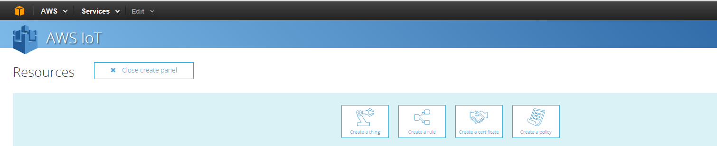

1. Choose “Create thing”
2. Create a name for the thing

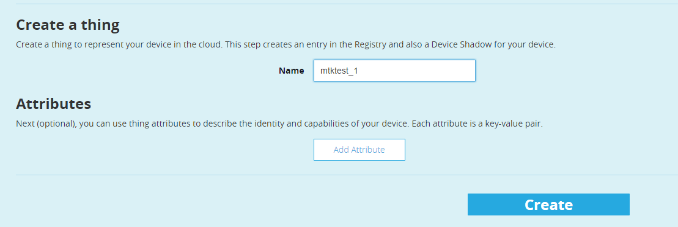

1. Click view thing



1. Choose “Connect a Device”



1. Please do like following screenshot and click “Generate Certificate and Policy”

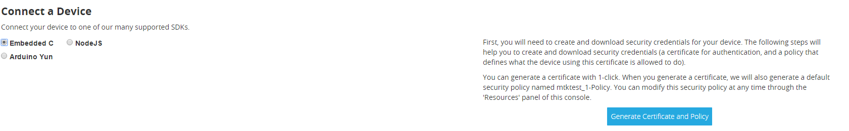

1. Download those 3 files to computer

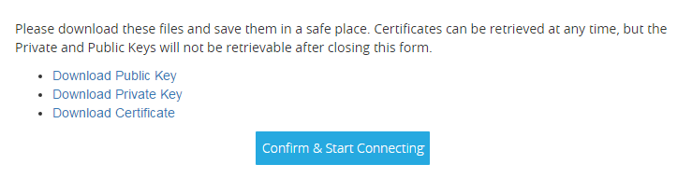

1. Please save them and rename it as you want.
2. Change LinkitOne to MS mode and copy those three files to LinkitOne flash memory
3. Switch back to UART mode
4. Click Return to Thing Detail

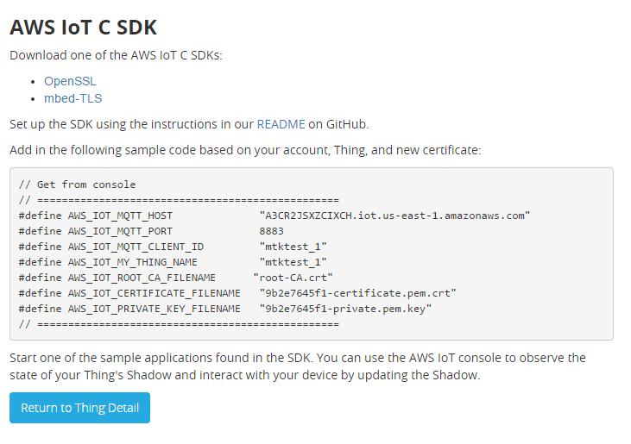

1. Download the LinkitOne source code from github:

<https://github.com/MediaTek-Labs/aws_mbedtls_mqtt>

1. Open aws_paho_shadow/aws_paho_shadow.ino with Arduino
2. In aws_mtk_iot_config.h, change the settings for wifi, your 3 certification files’ name and your AWS thing name. Currently, LinkitOne only supports the ip address to connect to the AWS server, please rewrite your ip address for your host name (default is “data.iot.us-east-1.amazonaws.com”, you could get the ip address by pint this host)

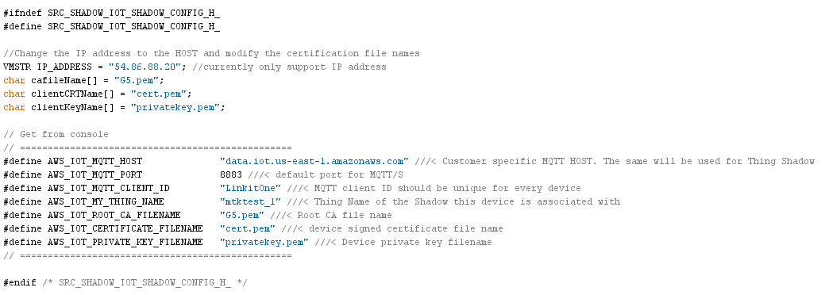

1. You will see in the AWS console, the data will be updated every time LinkitOne push the data to it.

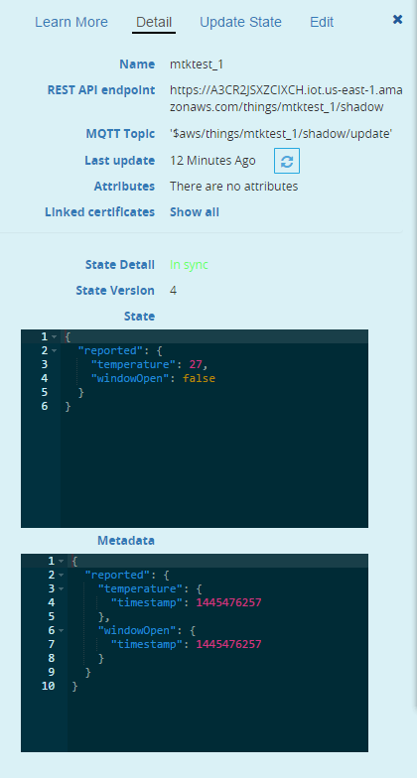

**MQTT message pub/sub example**

1. Go to [AWS IoT](https://aws.amazon.com/iot/) and open up the AWS IoT Dashboard



1. Choose “Create policy”
2. Fill out the Name(mtk_test_1), Action (iot:*) and Resource(*) like the following screen shot:

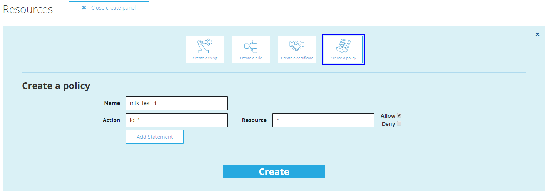

1. Click the “Create” button
2. Open aws_paho_mqtt.ino with Arduino
3. Change the settings in aws_mtk_iot_config.h:

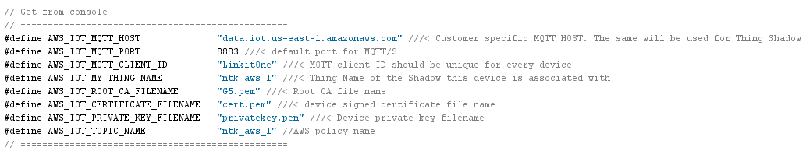

1. Like shadow example, change those certification files and also the AWS_IOT_TOPIC_NAME to the policy name you just created.
2. Run the sketch and see the logs from monitor:

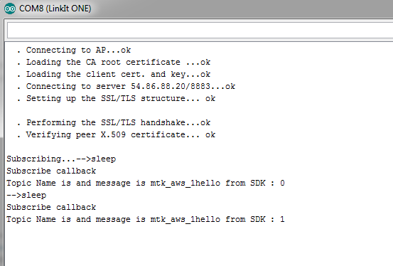

1. If you have another terminal like Mac, you could send a message through MQTT to it like following:

